Training for Better Health

Quality training of health professionals towards realization of

Programmes & Courses

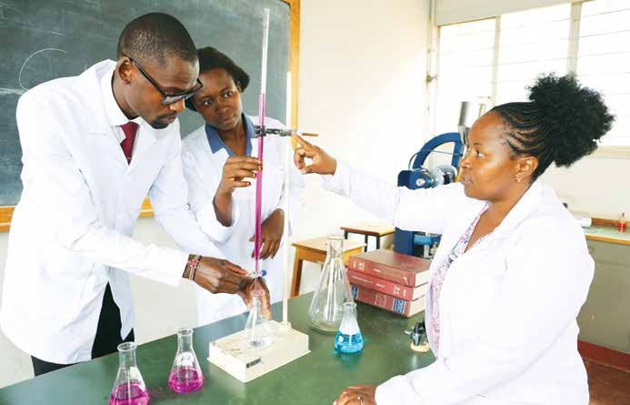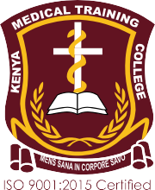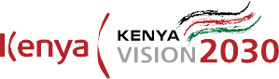

Quality training of health professionals towards realization of
www.kmtc.ac.ke
1

KMTC CORE STATEMENTS

Vision Statement
A model institution in the training and development of competent health professionals

Mission Statement
To produce competent health professionals through training and research, and provide consultancy services.

Core values

- Accountability
- Integrity
- Responsiveness
- Equity
- Teamwork
- Professionalism
- Creativity and innovation

KMTC CAMPUSES
KMTC Programmes:

Clinical Medicine and Surgery (Diploma and Higher Diploma)
- Medical Laboratory Sciences (Diploma and Higher Diploma)
- Orthopaedic and Trauma Medicine (Certificate and Diploma)
- Community Oral Health (Diploma)
- Medical Imaging Sciences (Diploma and Higher Diploma)
- Medical Education (Higher Diploma)
- Health Records and Information Technology (Certificate and Diploma)
- Pharmacy (Diploma and Higher Diploma)
- Dental Technology (Diploma)
- Nursing (Certificate, Diploma and Higher Diploma)
- Public Health (Certificate, Diploma and Higher Diploma)
- Nutrition and Dietetics (Certificate and Diploma)
- Occupational Therapy (Diploma and Higher Diploma)
- Health Promotion (Certificate, Diploma and Higher Diploma)
- Orthopaedic Technology (Diploma and Higher Diploma)
- Optometry (Diploma and Higher Diploma)
- Physiotherapy (Diploma and Higher Diploma)
- Medical Engineering (Certificate, Diploma and Higher Diploma)
- Short Courses

  - Bomet
  - Bondo
  - Bungoma
  - Busia
  - Chuka
  - Chwele
  - Eldoret
  - Embu
  - Garissa
  - Gatundu
  - Homabay
  - Imenti
  - Isiolo
  - Iten
  - Kabarnet
  - Kakamega
  - Kangundo
  - Kapenguria
  - Kapkatet
  - Kaptumo
  - Karen
  - Karuri
  - Kilifi
  - Kisii
  - Kisumu
  - Kitale
  - Kitui
  - Kombewa
  - Kuria
  - Kwale
  - Lake Victoria
  - Lamu
  - Lodwar
  - Loitoktok
  - Lugari
  - Machakos
  - Makindu
  - Makueni
  - Mandera
  - Manza
  - Mathare
  - Mbooni
  - Meru
  - Migori
  - Molo
  - Mombasa
  - Mosoriot
  - Msambweni
  - Mwingi
  - Murang’a
  - Nairobi
  - Nakuru
  - Nyamira
  - Nyandarua
  - Nyahururu
  - Nyamache
  - Nyeri
  - Othaya
  - Port Reitz
  - Rachuonyo
  - Rera
  - Siaya
  - Sigowet
  - Tana River
  - Taveta
  - Thika
  - Ugenya
  - Voi
  - Vihiga
  - Wajir
  - Webuye

2 www.kmtc.ac.ke
Training for Better Health

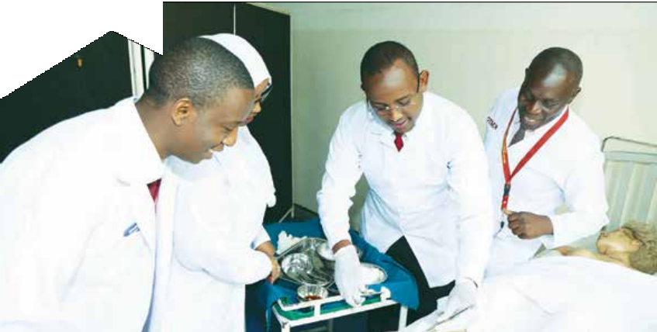Department of Clinical Medicine and Surgery

The Department offers programmes in Diploma and Higher Diploma

Academic Programme | Course | Duration | KMTC Campus Where Course is Offered | Entry Requirements
Diploma | Clinical Medicine | 3 years | Selected KMTC Campuses | KCSE mean grade of C with  C in English or Kiswahili, and C in Biology/Biological Sciences, C- in Chemistry/ Physical Science. C- in any one of the following: Mathematics, Physics/Physical Sciences
Higher Diploma | Pediatrics | 12 months | Nairobi and Kisumu | Diploma / Degree in Clinical Medicine and Surgery and registration with Clinical Officers Council
 | Ophthalmology and Cataract Surgery | 18 months | Nairobi
 | Family Health | 18 months | Nairobi, Embu, Nyeri, Nakuru, Mombasa, Machakos, Eldoret, Kisumu, Kakamega
 | Dermatology and Venereology | 18 months | Nairobi
 | Chest Medicine | 18 months | Nairobi
 | Ear, Nose and Throat (ENT) and Neck Surgery | 18 months | Nairobi and Nakuru
 | Reproductive Health | 18 months | Nairobi and Thika
 | Anaesthesia | 18 months | Nairobi, Nakuru, Eldoret, Kisumu, Kisii, Thika, Embu
 | Mental Health and Psychiatry | 18 months | Mathare
 | Ophthalmology Advanced Refraction and Low Vision | 18 months | Nairobi
 | Oncology and Palliative care | 18 months | Nairobi
 | Audiology and Hearing Care Technology | 18 months | Nairobi
 | Emergency and Critical  Care Medicine | 18 months | Nairobi
 | Orthopaedics | 18 months | Nairobi
 | General Ophthalmology | 18 months | Nairobi
 | Addictive Sciences | 12 months | Mathare | Diploma in any health related  course from KMTC or any other recognised institution.
Quality training of health professionals towards realization of
3

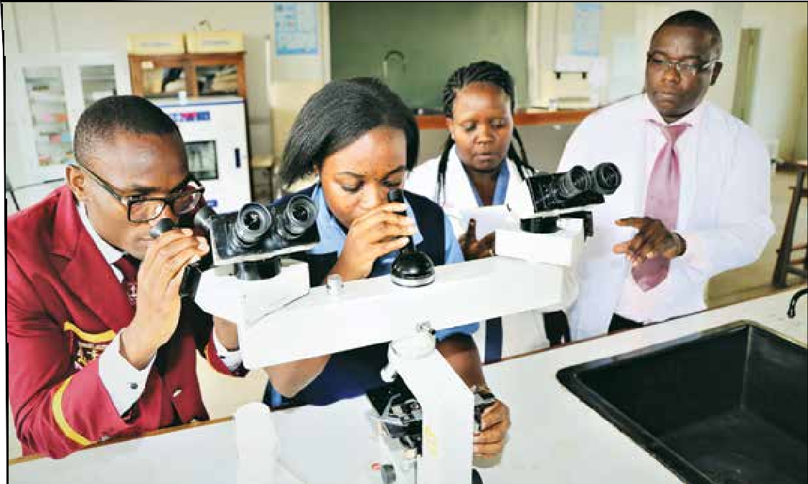Department of Medical Laboratory Sciences

The Department offers programmes in Diploma and Higher Diploma

Academic Programme | Course | Duration | KMTC Campus Where Course is Offered | Minimum Entry Requirements
 | Medical Laboratory Sciences | 3 years | Selected KMTC Campuses | Mean Grade C, C in English or Kiswahili, Biology/Biological Sciences and Chemistry/Physical Sciences
Diploma |  |  |  | C in either Physics/Physical Sciences or Mathematics
 | Diploma in Medical Laboratory (Upgrading from Certificate to Diploma) | 2 years | Selected KMTC Campuses | Certificate in Medical Laboratory Sciences from a recognized institution and Registered with KMLTTB
Higher Diploma | Microbiology | 1 year | Nairobi | Diploma in Medical Laboratory Sciences from a recognized institution.  Current registration with the Kenya Medical Laboratory Technicians and Technologists Board (KMLTTB)
 | Clinical Chemistry
 | Haematology
 | Histopathology & Cytology
 | Blood Transfusion Sciences
 | Parasitology and Entomology
 | Virology

Training for Better Health

www.kmtc.ac.ke
4

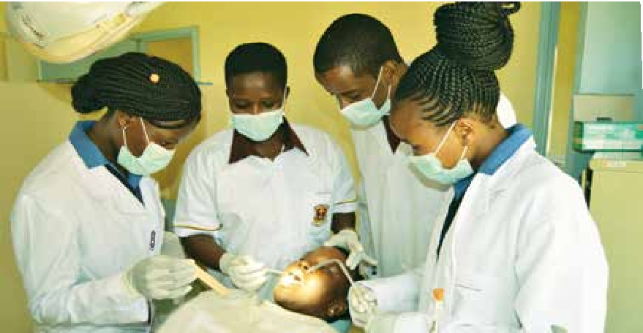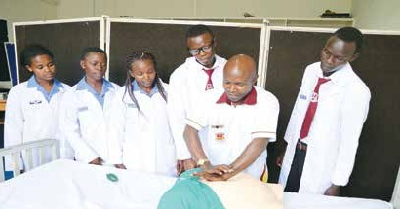Department of Orthopaedic and Trauma Medicine

The Department offers programmes in Certificate and Diploma (Pre- service and Upgrading)

Academic Programme | Course | Duration | KMTC Campus  Where Course is Offered | Entry Requirements
Certificate | Orthopaedic and Trauma Medicine | 2 years | Selected KMTC Campuses | Mean Grade C-, C- In English or Kiswahili,  and D+ in Biology/ Biological Sciences  D+ in any one of the following:, Mathematics, Physics/Physical Sciences, Chemistry, Woodwork, Metal work, Technical Drawing, Home Science, Agriculture
Diploma | Orthopaedic and  Trauma Medicine (Upgrading from Certificate to Diploma) | 2 years | Selected KMTC Campuses | Certificate in Orthopaedic and Trauma Medicine/Certificate in Orthopaedic Plaster Technology
 | Orthopaedic and Trauma Medicine (Pre- service) | 3 years | Selected KMTC Campuses | Mean Grade C, C in English or Kiswahili, C in  Biology/Biological Sciences and Mathematics or Physics/Physical Sciences  C- in any one of the following: Physics/Physical Sciences, Chemistry, Mathematics, Home Science, Agriculture

Department of Community Oral Health

The Department offers a Diploma programme

Academic  Programme | Course | Duration | KMTC Campus Where Course is Offered | Minimum Entry Requirements
Diploma | Community Oral Health | 3 years | Selected KMTC Campuses | An average C or above. Grade C or credit in English and Biology or Biological Sciences.  C- or credit in any two of the following: Chemistry, Physics or Physical Science, Mathematics.

Quality training of health professionals towards realization of 5

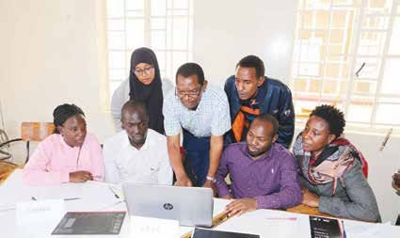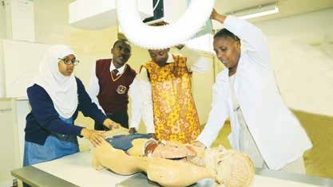Department of Radiography & Imaging (Medical Imaging Sciences)
Training for Better Health

www.kmtc.ac.ke

The Department offers programmes in Diploma and Higher Diploma

Academic Programme | Course | Duration | KMTC Campus  Where Course is Offered | Minimum Entry Requirements
Diploma | Radiography and Imaging | 3 years | Selected KMTC Campuses | Mean Grade C, C in English or Kiswahili  and Physics/Physical Sciences and Biology/Biological Sciences.  C- in any one of the following:- Mathematics, Chemistry
Higher Diploma | Ultrasonography | Full-time: 1 year  Part-time: 1½ years | Nairobi | Diploma in Medical Imaging Sciences or its equivalent.  Diploma in Radiography and Imaging (Medical Imaging Science) or its Equivalent from a recognized training institution
 | Computed  Tomography | Full-Time: 1 year
 | Magnetic Resonance Imaging
 | Radiography - Therapy | 1½ years (Full Time)

Department of Medical Education

The Department offers a Higher Diploma programme

Academic  Programme | Course | Duration | KMTC Campus Where Course is Offered | Minimum Entry Requirements
 | Medical Education | 1 year | Nairobi | Diploma in any one of the Health Care professions, basic knowledge in Computer is an added advantage
Higher Diploma
 | Health
 | Systems |  |  | Diploma in a Health related course OR a BSc.
 | Management | 1 year | Nairobi | in a health related course from a recognized
 | (Distance Learning) |  |  | institution

6

Department of Health Records & Information Technology

The Department offers programmes in Certificate and Diploma (Pre- service and Upgrading)

Academic Programme | Course | Duration | KMTC Campus Where Course is Offered | Entry Requirements
Certificate | Health Records and Information Technology | 2 years | Selected KMTC Campuses | Mean Grade C-, C- in English or Kiswahili, D in  Biology/Biological Sciences.  D- in Mathematics and D+ in any one of the following: Physics / Physical Sciences, Chemistry, General Sciences, Computer Studies, Agriculture, Home Science, Economics, Geography, Commerce and Business Studies
 | Health Records and Information Technology (In service category) | 2 years | Selected KMTC Campuses | KCSE Mean grade D+, with D+ in English or Kiswahili, D- in Mathematics. Working experience of 2 years in a Health Records and Information Department. Recommendation letter from Health Records & Information Officer in charge of the facility & Letter of appointment to the current position
Diploma | Health Records and Information Technology (Pre- service) | 3 years | Selected KMTC Campuses | Mean Grade of C, with C in English/Kiswahili, C- in Mathematics and D+ in Biology/Biological Sciences. C- in any of the following: Physics / Physical Sciences, Chemistry, General Sciences, Computer Studies, Agriculture, Home Science, Economics, Geography, Commerce and Business Studies
 | Health Records and Information Technology (Upgrading from Certificate to Diploma) | 2 years | Selected KMTC Campuses | Certificate in Health Records and Information Technology

Quality training of health professionals towards realization of 7

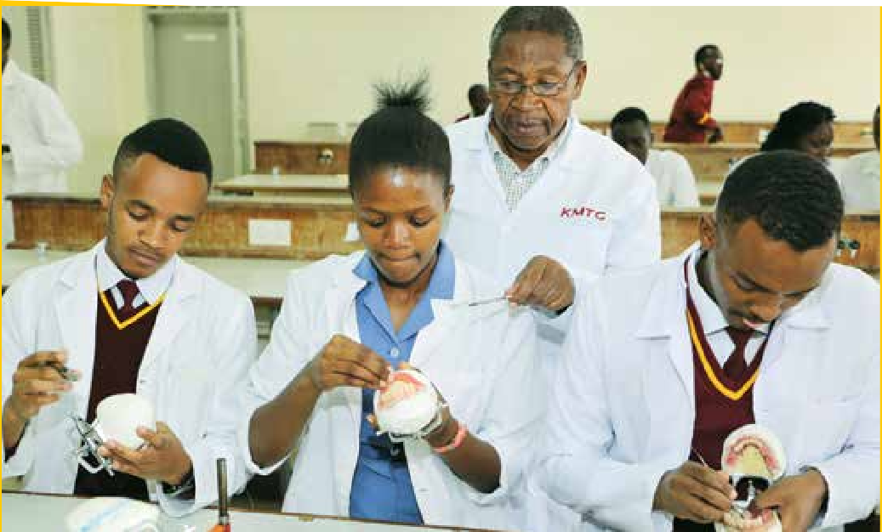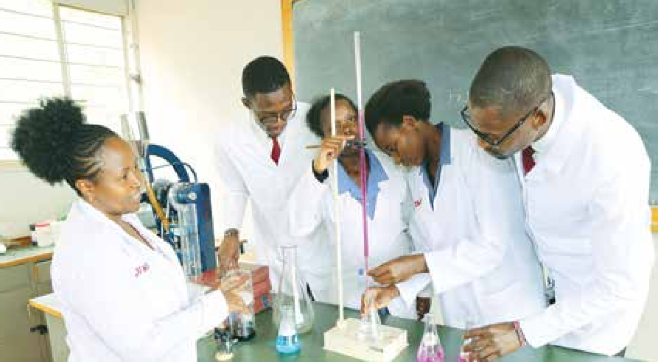Department of Pharmacy
Training for Better Health

www.kmtc.ac.ke

The Department offers Programmes in Diploma and Higher Diploma

 | Academic Programme | Course | Duration | KMTC Campus Where Course is Offered | Minimum Entry Requirements
 | Diploma | Pharmacy | 3 years | Selected KMTC Campuses | Mean Grade C, C in English or Kiswahili, Chemistry/Physical Sciences and Biology or Biological Sciences  C in any one of the following: - Physics/ Physical Sciences or Mathematics

Department of Dental Technology

The Department offers a Diploma programme
Academic Programme | Course | Duration | KMTC Campus Where Course is  Offered | Minimum Entry Requirements
Diploma | Dental Technology | 3 years | Selected KMTC Campuses | KCSE Mean grade of C, with C in English or Kiswahili, and Physical Sciences or Physics or Chemistry. C- in Biology and any one of the following:- Metal work, Mathematics,  Physics or Chemistry

8

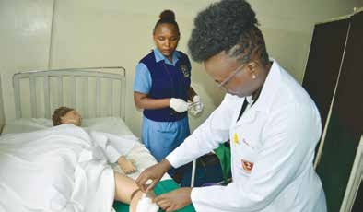Department of Nursing

The Department offers programmes in Certificate, Diploma (Pre-service and Upgrading) and Higher Diploma

Academic Programme | Course | Duration | KMTC Campus Where Course is  Offered | Entry Requirements
Certificate | Enrolled Community Health Nursing | 2 years | Selected KMTC Campuses | KCSE Mean grade of C-,  C- in Kiswahili or English & Biology or Biological Sciences. D+ in any one of the following: Chemistry or Physical Science or Physics or Mathematics
Diploma | Kenya Registered Community Health  Nursing (Upgrading from Enrolled Community Health Nurse) | 1½ year (full time) | Selected KMTC Campuses | Certificate in Kenya Enrolled Community Health Nursing (KECHN) and registered by the Nursing Council of Kenya
 | Kenya Registered Community Health Nursing (Upgrading from Enrolled  Community Health Nursing) | 2 years  (Distance Learning) | Selected KMTC Campuses
 | Kenya Registered Community Health Nursing (Upgrading from Enrolled Nurse /Midwife) |  |  | Certificate in Enrolled Community Health Nursing or Certificate in Midwifery, Registered by the Nursing  Council of Kenya
 | Kenya Registered Community Health Nursing (Pre-service) | 3 years | Selected KMTC Campuses | KCSE minimum aggregate C with the following specific requirements: C in English or Kiswahili and Biology or Biological Sciences. C- in Chemistry, Mathematics or Physics / Physical Sciences
 | Kenya Registered Nursing Mental Health and Psychiatry Nursing |  | Selected KMTC Campuses
 | Kenya Registered Nurse |  | Selected KMTC  Campuses
 | Kenya Registered Nurse/Mid- wifery  (KRN/M) |  | Selected KMTC  Campuses
Higher Diploma | Critical Care Nursing | 1 year | Nairobi, Thika,  Machakos, Kilifi | Diploma in Nursing or in Community Health Nursing (KRN/KRCHN), Diploma in Nursing (KRN/KRM).  Registration by a Nursing Council of respective country is a must. Applicant must demonstrate ability to cope with academic work and research comparable to any Higher Diploma training institution
 | Peri-operative Nursing | 1 year | Nairobi, Mombasa
 | Paediatric Nursing | 1 year | Kisumu
 | Palliative Care (Distance learning) | 1 ½ year | Nairobi
 | Psychiatric Nursing | 1 year | Mathare
 | Ophthalmic Care Nursing | 1 year | Nairobi
 | Nephrology | 1 year | Nairobi, Nakuru
 | Family Health Nursing (Distance  learning) | 1year | Nairobi, Gatundu,  Thika, Nakuru, Nyeri
 | Kenya Registered Nurse Anesthetist | 1 year | Kisumu
 | Geriatric Nursing | 1 ½ year (Distance  learning) | Nairobi

Quality training of health professionals towards realization of 9

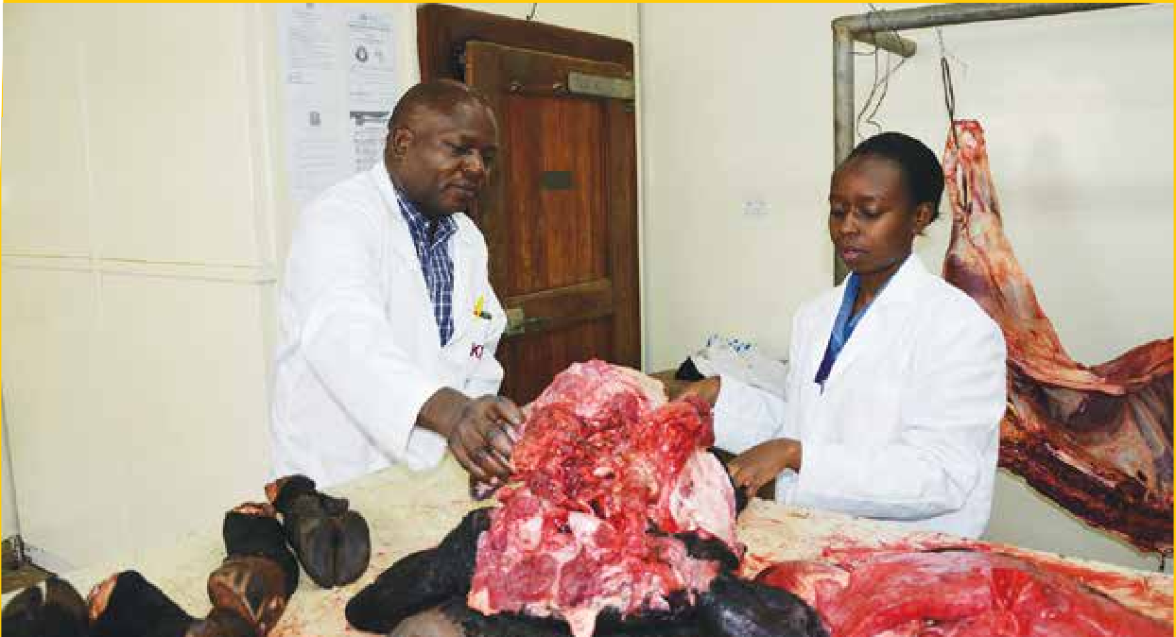Department of Public Health

The Department offers programmes in Certificate, Diploma (Pre-service and Upgrading) and Higher Diploma

Academic  Programme | Course | Duration | KMTC Campus Where Course is Offered | Minimum Entry Requirements
Certificate | Public Health | 2 years | Selected KMTC Campuses | KCSE Mean Grade of C-, with C- in English or Kiswahili, D+ in Biology / Biological Sciences, D in Mathematics and; D in any one of the following: Home Science, Physics, Chemistry, Agriculture, Building Construction, Technical Drawing, Electricity or Wood Work
Diploma | Public Health (Pre- service) | 3 years | Selected KMTC Campuses | Mean Grade C, C in English or Kiswahili and Biology/Biological Sciences  C- in Mathematics and any one of the following: Physics/Physical Sciences, Chemistry
 | Public Health (Upgrading from Certificate to Diploma) | 2 years | Selected KMTC Campuses | Certificate in Public Health (Environmental Health Sciences)
Higher Diploma | Food Science and Inspection | 1 year | Nairobi | Diploma in Public Health (Environmental Health Sciences)
 | Solid Waste Management |  |  | Diploma in Public Health (Environmental Health Sciences)
 | Occupational Health and Safety |  |  | Diploma in any of the following: Public Health, Nursing, Clinical Medicine, Dental Technology, Orthopaedic Technology, Occupational Therapy and Medical Engineering
 | Epidemiology |  |  | Diploma in Public Health, KRCHN, Clinical Medicine, Medical Laboratory Sciences, Pharmacy, Nutrition, Health Records & Information, Community Oral Health

Training for Better Health

www.kmtc.ac.ke
10

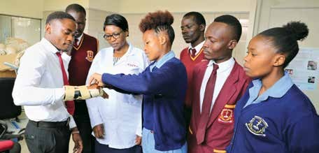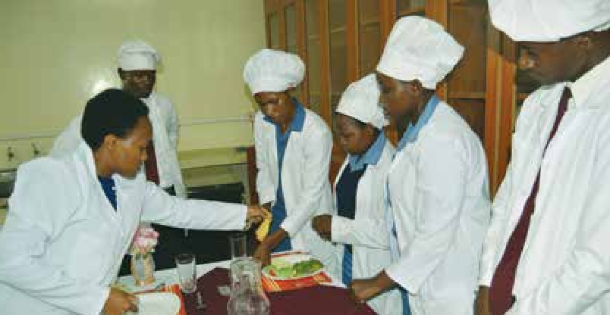Department of Nutrition and Dietetics

The Department offers programmes in Certificate and Diploma (Pre-service and Upgrading)

Academic Programme | Course | Duration | KMTC Campus Where Course is Offered | Entry Requirements
Certificate | Nutrition & Dietetics | 2 years | Selected KMTC Campuses | KCSE Aggregate Grade D+, with D+ in English or Kiswahili and Biology or Biological Sciences. D in Chemistry/Physical Sciences. D in any one of the following: Physics, Mathematics, General Science, Home Science, Agriculture or Business Studies
Diploma | Nutrition & Dietetics (Upgrading from Certificate to Diploma) | 2 years | Selected KMTC Campuses | Certificate in Nutrition and Dietetics. Two years working experience
 | Nutrition & Dietetics (Pre-service) | 3 years | Selected KMTC Campuses | KCSE Aggregate Grade C-, with C- in English or Kiswahili, and Biology or Biological Sciences. D+ in Chemistry/Physical Sciences, D in any one of the following: Physics, Mathematics, Home Science, Agriculture, General Sciences or Business Studies

Department of Occupational Therapy

The Department offers programmes in Diploma and Higher Diploma
KMTC Campus Where Course is Offered

Duration

Course
Academic
Programme

Minimum Entry Requirements

Diploma

Occupational Therapy

3 years

Selected KMTC Campuses
KCSE Mean grade of C, with C in English or Kiswahili and C- in Biology or Biological Sciences. C- in any one of the following: Physics / Physical Sciences, Chemistry, Mathematics, Agriculture or Home Science

Quality training of health professionals towards realization of 11
Nairobi

1 year
Community Based Rehabilitation
Higher Diploma
Health care professionals with a minimum of a Basic Diploma from the KMTC and other accredited training institutions

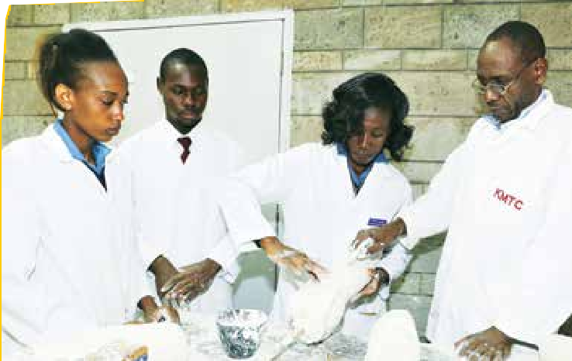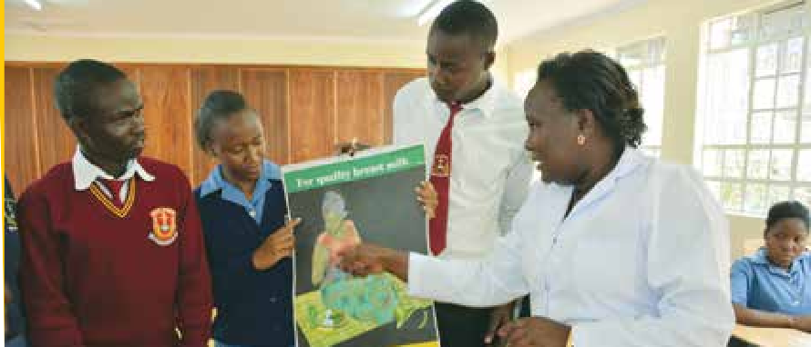Department of Health Promotion and Community Health

The Department offers programmes in Certificate, Diploma and Higher Diploma

Academic  Programme | Course | Duration | KMTC Campus Where Course is Offered | Minimum Entry Requirements
Certificate | Community Health Assistant | 2 years | Selected KMTC Campuses | KCSE Mean Grade of C-, with D+ in English or Kiswahili, D+ in Biology OR Biological sciences. D in any of the following; Mathematics, Chemistry, Physics or Physical Sciences or Foundation course in Community Health
 | Health Promotion for the Deaf (CHPD), deaf students only | 2years | Selected KMTC Campuses | KCSE Mean Grade D+, with D+ in English or Kiswahili or Kenya Sign Language, D in Biology and any one of the following: Mathematics, Chemistry, Physics, Agriculture, Social Studies or C.R.E/I.R.E
Diploma | Health Promotion | 3 years | Selected KMTC Campuses | KCSE Mean Grade of C, C in English or Kiswahili and C- in Biology/ Biological Sciences, D+ in any one of the following: Mathematics, Physics/Physical Science or Chemistry
Higher Diploma | Health Education and Promotion | 1 year | Nairobi | Any health related Diploma / Social Science from a recognized institution.
 | Community Health and HIV Management | 1 year | Nairobi | Any health related Diploma

Department of Orthopaedic Technology

The Department offers programmes in Diploma and Higher Diploma
Minimum Entry Requirements
KMTC Campus Where Course is Offered
Duration
Course
Academic
Programme

Diploma

Orthopaedic Technology

3 years

Selected KMTC Campuses
KCSE with Mean Grade of C , with C in English or Kiswahili and C- in Biology/ Biological Sciences, D+ in any of the following: Physics/Physical Sciences, Mathematics, Chemistry, Woodwork, Metalwork or Technical Drawing

Training for Better Health

Diploma in Orthopaedic Technology or its equivalent

Nairobi
1 year (Distance learning)
Orthotics Option
Higher Diploma

www.kmtc.ac.ke
12

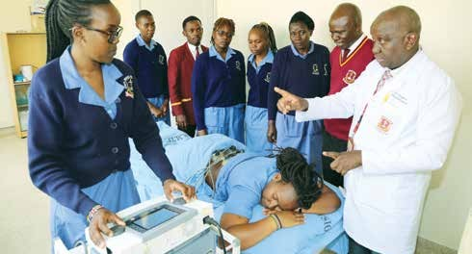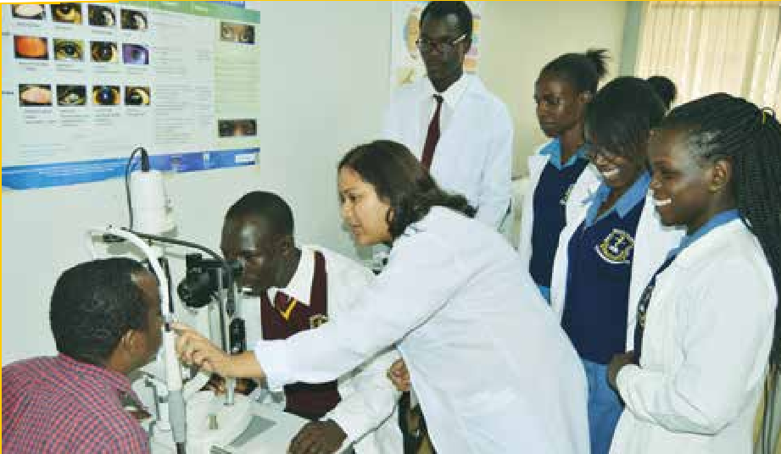Department of Optometry

The Department offers Programmes in Diploma and Higher Diploma

Academic  Programme | Course | Duration | KMTC Campus Where Course is Offered | Minimum Entry Requirements
Diploma | Optometry | 3 years | Selected KMTC Campuses | Mean Grade C, C in English or Kiswahili and Mathematics  C- in the following: - Biology/ Biological Sciences, Physics/Physical Sciences
Higher Diploma | Contact Lenses | 1 year | Nairobi | Diploma in Optometry or its equivalent from a recognized institution

Department of Physiotherapy

The Department offers Programmes in Diploma and Higher Diploma

Academic  Programme | Course | Duration | KMTC Campus Where Course is Offered | Minimum Entry Requirements
Diploma | Physiotherapy | 3 years | Selected KMTC Campuses | KCSE minimum aggregate of C with C in English or Kiswahili, C- in Biology. C- in any two of the following:- Chemistry, Physics/Physical Sciences and Mathematics
Higher Diploma | Orthopedic Manual Therapy (OMT) | 18 Months (Distance learning) | Nairobi | Diploma, Bachelor’s Degree or Master’s degree in Physiotherapy. Registered with Physiotherapy Council of Kenya
 | Neurorehabilitation | 18 Months (Distance learning) | Nairobi

Quality training of health professionals towards realization of 13

Department of Medical Engineering

The Department offers programmes in Certificate, Diploma (Pre-service and Upgrading) and Higher Diploma

Academic Programme

Course

Duration
KMTC Campus Where Course is Offered

Minimum Entry Requirements

Certificate

Diploma

Medical Engineering Technology

Medical Engineering Technology (Pre- service)

Medical Engineering Technology (Upgrading from Certificate to Diploma)

- years

- years

2 years

Selected KMTC Campuses

Selected KMTC Campuses

Selected KMTC Campuses
KCSE Mean Grade of C-, with C- In English or Kiswahili, D in Mathematics and D in Physics/Physical Sciences or Chemistry. D in any one of the following: - Chemistry, Biology/Biological Sciences, Electricity, Metal Work, Technical Drawing

Mean Grade C, C in English or Kiswahili and Mathematics and Physics/Physical Sciences C- in any one of the following: - Biology/ Biological Sciences, Chemistry, Electricity, Metal Work, Technical Drawing

Certificate in Medical Engineering Technology OR an equivalent from a recognized institution

Higher Diploma
Diagnostic Equipment

Therapeutic Equipment
Dialysis

1 year

Nairobi

Diploma in Medical Engineering Technology, OR an equivalent from a recognized institution

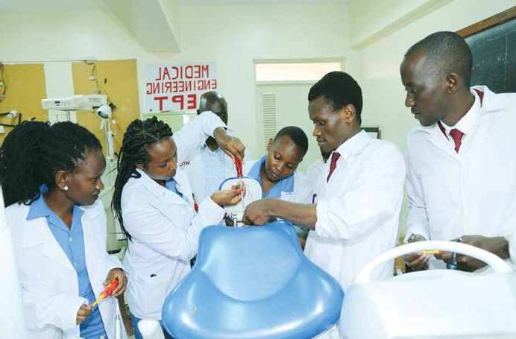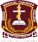
14 www.kmtc.ac.ke
Training for Better Health

SHORT COURSES
The following short courses are on offer in various campuses. Short courses are offered to individuals, corporates or tailor-made for organizations. Enroll today to meet your Continuous Professional Development (CPD) requirements and remain relevant in your profession. Application shall be made online by logging in to the KMTC portal – available at www.kmtc.ac.ke and choose the option short courses and follow the steps as prompted by the system.
Course Description Target Group Campus Duration Fees (KES)

HIV Testing Services (HTS)

Echocardiog- raphy

Monitoring & evaluation

Healthcare Entrepreneur- ship

Safe
Phlebotomy

Infection
Prevention

First Aid and Basic Life Support

Sign Language for Health workers
The course prepares participants to provide comprehensive HIV Testing Services (HTS), strengthen linkage to care and treatment and other post-test services, define target populations who may particularly benefit from HIV testing services (accredited by NASCOP)

The course enables the participants to perform and interpret echocardiograms and ultrasound imaging of the heart and blood flow, gain expert understanding of the latest scientific laboratory equipment including use of the clinical skills laboratory and echocardiographic machines

The course provides participants with requisite knowledge to design and implement healthcare projects to meet the populations’ health needs, and promote evidence-based decision making. Graduates work with local & international NGOs, public & private sector projects

This course empowers participants to become healthcare entrepreneurs or to manage their healthcare businesses profitably

The course gives participants knowledge and skills to perform safe phlebotomy, provide quality specimens for laboratory tests, handle phlebotomy equipment and avoid occupational exposure

This course will equip participants with knowledge to prevent and control infections in different healthcare set ups

This course empowers participants to prevent and manage life threatening emergencies. Training follows approved international guidelines

The course prepares participants to communicate in sign language, helping the deaf access healthcare in line with Universal Health Coverage (UHC)

Health workers OR anyone interested in working in HIV/AIDS programs (minimum Diploma in any health related field)

Radiographers OR Healthcare
professionals with a background in medical physiology

Project Managers, Project Officers, Project Assistants, Health Information Officers, practitioners involved in designing, supervising, coordinating
or monitoring interventions (minimum Diploma in any health related field)

Healthcare workers and those in healthcare business

Laboratory Technicians, Technologists, Scientists, Medical Officers, Clinical Officers, Nurses, other certificate or diploma holders in health related courses

Healthcare workers, hospital support staff, hospital administrations, HTS
counselors, caregivers in general

Drivers, Hoteliers, Police officers, Security guards, County emergency/ Disaster teams, teachers, etc

Health workers & those interested in working with the deaf; minimum requirement is certificate in any course
Lake Victoria Nairobi Kisumu Machakos Kitui
Lodwar Homa Bay Siaya Kapkatet

Nairobi

Siaya Nairobi Murang’a Rachuonyo

Nairobi

Lake Victoria Nyeri
Kitui Machakos Nairobi

Makindu Rachuonyo Kitui
Thika Nairobi
Lake Victoria Nyeri
Isiolo Eldoret Makindu Kwale Rachuonyo Thika Machakos Msambweni

Molo Murang’a

3 weeks
Open

- Months (part-time) (Thursday, Friday & Saturday)

Open

- weeks (full
time)

7 Weeks (part- time)

Open

1 week fulltime & 1 week practicum

3 days
Open

3 day (one module)

One week (three modules)
Open

2 weeks
(Evening)
Open

6 months (3
fulltime & 3
practicum)
Open

24,500

90,500

40,500 (full
time)

60,500 (part-
time)

25,500

15,500

3,500 (3
days) (For
Health
Professionals)

6,500 (one week) (for non-health professionals

10,500

60,500

Quality training of health professionals towards realization of 15

Course | Description | Target Group | Campus | Duration | Fees (KES)
Foundation in Community Health | This is a foundation course for those interested to build a career in community health, such as Community Health Assistant, in support of UHC | Form four leavers and anyone interested in working at community level; minimum requirement D Plain | Lodwar, Taveta,  Mbooni, Kwale, Imenti, Manza, Lugari, Isiolo, Makindu, Embu, Sigowet Kakamega Mandera  Tana River | 6 months  fulltime  Open | 32,700
Medical Engineering (Basic electronics) | The course participants will gain and apply knowledge to build, service, repair and maintain various electronics equipment | Technicians OR those wishing to pursue technician career with a bias to medical equipment | Eldoret | 3 months (part-time)  Open | 25,500
Adherence Counselling | The course prepares participants to provide counselling services to HIV positive clients, strengthen adherence to treatment and minimize resistance to ARVs  (Accredited by NASCOP) | HTS Counsellors,  Healthcare  workers providing comprehensive care (working in CCCs). Diploma holders in medical related course or Social Sciences interested in HIV/AIDS programs | Nairobi  Lake Victoria Lodwar Homa Bay | 1 week | 20,500
Food Hygiene and Inspection | The course helps participants to source and prepare/handle food hygienically therefore reducing food transmitted diseases | Food handlers –hotels, restaurants, kiosks, home etc | Kwale  Kakamega Kitui Manza Karuri Kabarnet | 6 weeks  Open | 15,500
Counseling skills for Healthcare Professionals | The course prepares  participants to provide holistic clients’ care using counseling approaches; prevent burnouts among themselves, improve communication skills and interpersonal relations at work place | Health workers , social  workers, community health workers, teachers  Anyone interested in providing counseling services (minimum entry certificate) | Mathare  Kwale | 6 months (part-time)  Open | 60,500
Nutrition in Critical Care | The course prepares participants to assess nutritional needs, formulate appropriate nutritional interventions and apply integrated approach to manage critically ill patients | Health Care Workers  (Doctors, Nurses, Clinical Officers, Nutritionists, Pharmacy Technologists, Lab Technologists and Community Health Workers) | Thika | 2 Weeks (Full time) | 25,500
Peadiatric Neurorehabili- tation. | Diploma, Orthopaedic  Manual Therapy (OMT) Bachelor’s Degree or Masters in Physiotherapy | Practicing Physiotherapists | Nairobi | 2 Weeks | 15,500
Women’s Health – Level I | Diploma, OMT, Bachelor’s  Degree or Masters in  Physiotherapy | Practicing Physiotherapists | Nairobi | 2 Weeks | 15,500
Vestibular  Rehabilitation | Diploma, OMT, Bachelor’s  Degree or Masters in  Physiotherapy | Practicing Physiotherapists | Nairobi | 1 Week | 15,500
Women’s Health - Level III | Diploma, OMT, Bachelor’s Degree or Masters in Physiotherapy | Practicing Physiotherapists. Must have completed level I and II of the course | Nairobi | 2 Weeks | 20,500
Cardiopulmo-  nary Rehabili- tation | Diploma, OMT, Bachelor’s Degree or Masters in  Physiotherapy | Practicing Physiotherapists | Nairobi | 2 Weeks | 15,500
Exercise Theory and Prescription | OMT Physiotherapists | Practicing Physiotherapists | Nairobi | 2 Weeks | 15,500
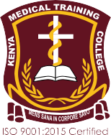Successful Candidates will be sent to train in any of our 71 Campuses where the courses are offered
FOLLOW THE APPLICATION GUIDELINES ON THE WEBSITE (Website: www.kmtc.ac.ke)
16 ww
w.kmtc.ac.ke Training for Better Health
For More Information Contact:
The Chief Executive Officer, Kenya Medical Training College
P.O. Box 30195-00100, Nairobi.
Tel: 020-2725711/2/3/4, 020-2081822/3, 0737-352543 / 0706-541869
Email: info@kmtc.ac.ke. Website: www.kmtc.ac.ke.
: @Kmtc_official. : @KMTCofficial

